# Compass MED D - Reading Prior Call/Case Notes (Compass)

Overview

Why Reading Notes is Important

Making a Call More Conversational

Examples of Where Referring to Prior Notes Are Critical

Outbound Campaigns

Beneficiary has a request

Repeated Calls

Viewing Alerts

Viewing Support Task History

Related Documents

|  |
| --- |
| Overview |

Reading and writing detailed alerts and case notes is very important in providing 5-Star Customer Service. A first call resolution reduces the number of calls our beneficiaries place to us, which then reduces their frustration with their Medicare Prescription Drug Plan and the eventual number of CTMs.

Although it might not be crucial to read all alerts and case notes, every effort should be made to not only ask beneficiaries if they had called us recently about the same issue, but it should always be a standard practice to look for notes to be well informed so you can provide great Customer Service.

Documentation in Compass is not only important for audits and CMS reviews, but it is an invaluable tool for assisting the beneficiary.

The primary errors when CCRs handle calls are directly linked to not properly researching a beneficiary’s issue, both in the alerts and case notes left in the account and by not properly accessing all the systems available to the CCR to help assist the beneficiary.

Proper documentation in Compass will provide you the following information to assist on a call:

* **Who** called?
* **What** the caller is calling about / **What** the issue is
* **Where** the problem exists (**Example:** Mail order, point of sale, etc.)
* **When** the issue occurred or is anticipated (in the past or future date)
* **Why** is it an issue for the beneficiary / **Why** it should be resolved

Top of the Document

|  |
| --- |
| Why Reading Notes is Important |

**So why is checking alerts and case notes so vital?**

It is a strong possibility that the person who is calling is not calling for the first time because:

* Their issue was not previously resolved
* Received a communication that caused them to call (letter/received a call)
* Were advised to obtain additional information

**For this reason, you should always assume that there are notes in their account that can assist you to be prepared so you can show the beneficiary that you are there to support them with their issue.**

After looking at the notes, you will discover several possibilities including but not limited to:

* Directions on what to do with the beneficiary if they call in.
  + Warm transfer them
  + Advise them of something
* A history of calls related to the same issue.
  + Allows you to avoid duplicating efforts
  + Determine what would be the next step to take or questions to ask to help dig deeper
* Outbound calls made on specific information to share with beneficiary.

By looking at the notes, you can proactively address the issue that the beneficiary is facing without requiring them to spend time re-explaining the history all over again.

Top of the Document

|  |
| --- |
| Making a Call More Conversational |

A major complaint for Grievances from beneficiary frustration is repeatedly put on hold for long periods of time while CCRs conduct “research” or say “let me look into your account”. How often have you called into somewhere and been put on hold, not a fun experience is it?

The same applies to our beneficiaries who just want their issue resolved. This is even worse when their first conversation after authenticating is putting them on hold.

**AVOID** putting them on hold.

After you complete your authentication process and the caller asks their question, consider saying:

* “I heard you say you called before, let me take a look at your account to be better aware of your recent activity.”
* “Have you called us about this issue before?”
* “Let me look into your account to look into any prior calls or activities that will equip me to better serve you.”

Once you are in the notes, you can easily transition into:

* “I see in your account that you’ve called recently about ___________”
* “I see that you were recently called by the Late to Fill team. Let me warm transfer you to them so they can assist you.”
* “I noticed that we recently sent you some ______________”

Keep the flow of communication going to demonstrate your 5-Star Customer Service and assisting the beneficiary so they will not have to call back again for that same issue and ensure you recap, so that you ensure you covered everything they need.

Top of the Document

|  |
| --- |
| Examples of Where Referring to Prior Notes Are Critical |

Nobody wants to give inaccurate information, but regrettably, it has been happening over and over again. Why? Because the person handling the call did not refer to prior notes to know there was something particular that needed to be shared or the way to properly handle the issue.

Here are a few examples of different recent categories where this has occurred repeatedly.

### Outbound Campaigns

Often, beneficiaries call in saying they received a voice mail from someone saying they represented CVS and were trying to get more information on why they called.

An example of this is the Outbound calls regarding Late to Fill (LTF) which is a program conducted by the LTF team composed of pharmacists and agents conducting outbound calls to beneficiaries who are identified as having a late to fill medication including Oral, Diabetic, Cholesterol-lower, Blood Pressure, etc.

Regrettably, in some cases the CCR tells the beneficiary that it is a potential scam, or that they are unaware of that program and unable to help.

One situation would find the CCR leaving a case comment where they advised the beneficiary that the phone call could have been a potential scam, because the beneficiary isn’t available in the [CVS Caremark Outbound Phone Numbers Displaying on Caller ID](CMS-PCP1-042944)work instruction. If the CCR had taken the time to review the Member’s Recent Cases Panel on the Case Details Landing Page, they would have realized that they should transfer to the Late to Fill team.

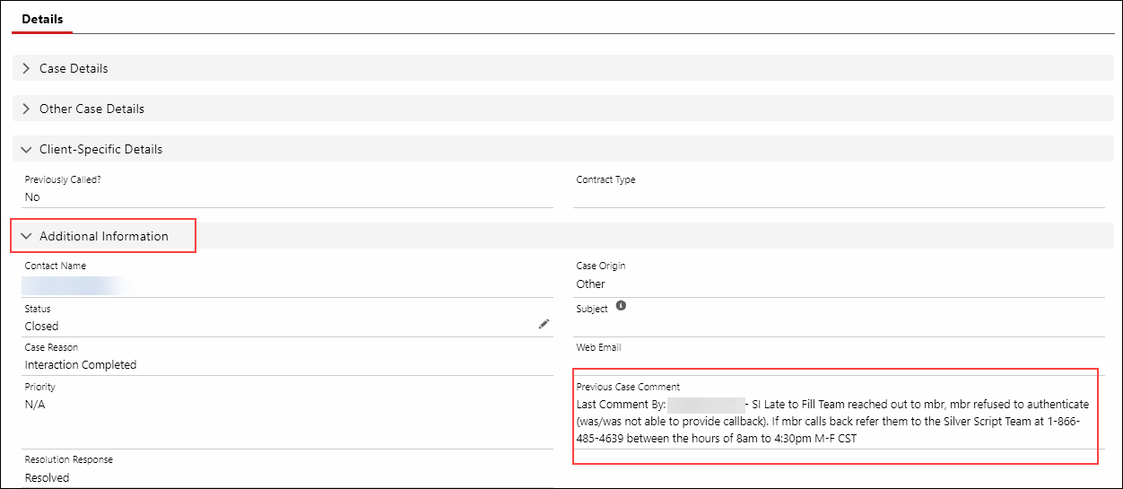

### Beneficiary has a request

Beneficiaries may call in to request updates to their accounts, overrides or requesting to disenroll.

Reviewing Member’s Recent Cases will provide:

* Whether or not **ALL** the options are provided as required by CMS
* Information that was provided and if additional steps are expected
* Whether prior calls were made
* If inaccurate information was given

A prime example is one of the major drivers of CTMs – Disenrollment. In this situation we see several CCRs requesting the same action (for example submitting a Support task to send them a disenrollment form), which could be avoided by looking into what was already sent and confirming receipt.

Possible statements could be:

* “I see here that on a previous call, you requested a disenrollment form. Did you receive the form that was sent out, and do you have any questions about the information it requires?”
* “I can provide you additional options if we are having difficulty getting the form sent out to you, or if you have not received it yet.”
* “I see a form was requested for you, but we have not yet received it back. From what you're telling me, you seem to qualify for an SEP, so let's discuss all of the options available to you.”
* “I see an activity was set up to send you the disenrollment form. Let me walk through all the options again, so maybe we find one that might work better for you.”
* “I see a form was scheduled to be sent to you. Did you receive it?” If they say no, follow up, “Can you advise me of your address so I can confirm we have the correct one on file.”
* “I see a form was scheduled to be sent to you, but we have no record the form has been received back from you. I see you do qualify for an SEP, so to avoid any further delays let me tell you all the options so we can find one that may work quicker for you.”

Although we never want to lose a beneficiary, we still need to provide 5-Star Customer Service to everyone who calls in.

### Repeated Calls

Either through comments by the caller, or through proper probing into the issue, you can uncover that they have made repeated attempts to get someone to properly assist them.

* “I have called several times, and nobody seems to be able to help.”
* “This is the 3rd time this month I’ve called.”
* Asking the beneficiary
  + “Is this the first time you’ve called about this issue?”
  + “Have you contacted us about this before?”

### Viewing Alerts

Follow these Work Instructions on how to view alerts and recent cases.

* Viewing Client, Mail and Member Alerts:  [Compass - Viewing, Adding, and Editing Alerts](https://thesource.cvshealth.com/nuxeo/thesource/#!/view?docid=36c941d2-25a6-4075-993d-f12deb31be18)
* Viewing Order Level and Prescription level alerts: [Compass - Mail Order History / Order Status](https://thesource.cvshealth.com/nuxeo/thesource/" \l "!/view?docid=0ad0ab77-cb2e-4521-8f97-659304a0c8f8)
* Viewing Member’s Recent Cases:  [Compass - Viewing Member's Recent Cases and Viewing PeopleSafe Activity (RM Task Information) in Compass](https://thesource.cvshealth.com/nuxeo/thesource/#!/view?docid=ab5a6f09-8f08-424b-bff7-b1aa5cfc4d6a)
* Viewing Medicare D Alerts: [Compass MED D - Medicare D Alerts](https://thesource.cvshealth.com/nuxeo/thesource/" \l "!/view?docid=7f5d83d4-94b0-4a59-9b40-3e9ce8b08b62)

In addition, use tools such as LINKs, FileNet, and One-Click to view appropriate letters when they indicate they received a letter. By understanding what was communicated, you can then follow the proper procedures to properly assist them.

Top of the Document

|  |
| --- |
| Viewing Support Task History |

Perform the steps below:

|  |  |
| --- | --- |
| **Step** | **Action** |
| **1** | Access the Beneficiary’s account in Compass and click the **Case** tab.    **Result:** The Case Details Landing Page displays. |
| **2** | Using the scroll bar between the two panels, scroll down to the **Member’s Recent Support Tasks** section and click the **View All** hyperlink.    **Result:** The **Member’s Support Task** tab displays, and any existing Support Tasks display under the **Support Task** header.      **Notes:**   * List only displays Support Tasks associated with the current beneficiary’s Membership ID and does not include linked accounts. If the beneficiary has multiple accounts, each account must be searched separately. * Click the **Refresh** hyperlink to view recently submitted Support Tasks as needed. |
| **3** | Review the **Type** column to determine if there were any previous Support Tasks related to the current issue.     * To view details, click the corresponding hyperlink to open the Support Task.     **Result:** **ST <#>** screen displays. |

Top of the Document

|  |
| --- |
| Related Documents |

**Parent SOP:** CALL-0048: [Medicare Part D Customer Care Call Center Requirements-CVS Caremark Part D Services, L.L.C.](https://policy.corp.cvscaremark.com/pnp/faces/SecureDocRenderer?documentId=CALL-0048&uid=pnpdev1)

**Abbreviations/Definitions:** [Abbreviations / Definitions](CMS-2-017428)

Top of the Document

Not To Be Reproduced Or Disclosed to Others Without Prior Written Approval

**ELECTRONIC DATA = OFFICIAL VERSION / PAPER COPY = INFORMATIONAL ONLY**